
South East European University
Faculty of Contemporary Sciences and Technologies

1st Project in Object Oriented Programming

Bank Management System

Student: Mentor:
Dardan Iseni Lejla Abazi-Bexheti
Tetovo, May 2020
Contents

Contents 2
1 Introduction 3
3 Problem description 4
4 Representation of the project in UML 5
5 Solution 6

Introduction

On the following pages, you will be introduced to a project developed by Dardan Iseni- Student of Computer Science and Technologies in C++ programming language. These researches are related to one of the most sophisticated programming paradigms-Object Oriented Programming.
The project resulted as a collection of ideas, knowledge and creativity of the student himself due to the end of the first semester where the students are confronted with the mentioned programming branch. The objective of all this work was to apply all C++ Programming knowledge including different algorithms linked to classes and objects,inheritances,polymporphisms except files,on a real world project.

For this purpose, to mirror every theoretical explanation to an understandable version, I decided to create a Bank Management System, where I will “melt” all of the above mentioned elements, that will help managing clients and employees of a start up business. In this case an admin will have a variety of options for his clients and employees and the flow of the business will be smoother at the same time.

To summarize, I dedicate this project to all the students who want to bring out more mastery from their University journey in C++ Programming language, which will certainly make the process of studying easier and solid to everyone who will pay the required attention to each of the pages below.

Project Problem

My idea of this project as I mentioned before was to create a Bank Management System, where the admin will obviously be the head of the project and system at the same time.
He will be able to manipulate with bunch of things in two main classes: User’s(Client) and Employees’ class starting from the adding ,sorting and filtering their data and also printing them visually.
Like any other project that contains its different requirements, this project had a plenty of them as well..
Here are some of the most important ones:
- Including classes and objects
- Different Inheritances(Multilevel,Hierarchical,Hybrid)
- Virtual and Pure Virtual functions
- Separating interface from implementation
- Overloaded functions
- Documentation

Every thing was pretty clear to me while working on this whole thing, but let me express the fact that, the main issue stands for the implementation of both the virtual and pure virtual functions, since only one virtual function was needed for my project and the range possibilties and options was not that wide.

Representation of the project in UML.

As you already know, the Unified Modeling Language (UML) is a general-purpose, developmental, modelling-language in the field of software engineering that is intended to provide a standard way to visualize the design of a system.
Here is the basic format of a Management System represented in UML.

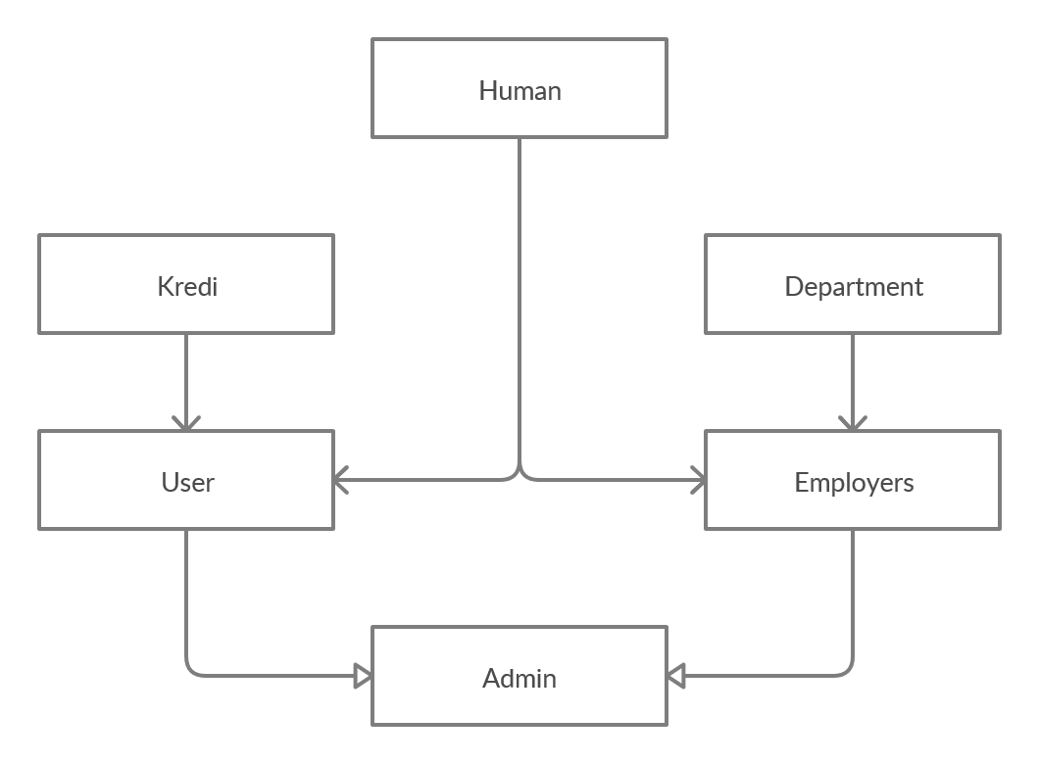

Solution
As we can see on the UML graph we have in total six classes.
The first class is “HUMAN” which contains basic informations (personal details) about users and employees such as: name, surname, ID, adress(city) and all the set and get functions that are needed for them.This class is the base class(parent class), from which the two main classes-User and Employees class(child class) inherit all the attributes, methotds and functions from the base class, so this can be called an hierarchical inheritance.
Also we have two classes that inherit with single level inheritance Credit and Department.
Credit class inherits from the User class, which contains the private attributes that will also be used in the Credit class such as: interest value of credit rate and installments,their set and get functions and the main function for calculating the credit, where its calculation is depended from the private attributes.
Department inherit to Employer and has variables needed for department job position experience and salary.Set and get funtions also as we know but what is characteristic here that set functions are not like others where we just set the variable on the parameter of the function thoose set functions when we call they list their choices and add them to the function.
Two important classes that inherits all these classes are User and Employer.
The User class as I mentioned inherits from Human and from Credit and has private members like income outcome deposit and as public we have here a virtual function Print Users that helps us to print users at derived class and this class too.
The Employer class is quite similar to the User class just with a small difference in inheritance, since it inherits the from department not from the Credit class. Here we also a virtual function called Print Employees.

At the end we have an Admin class which inherits from both User and Employee class and this type of inheritance is called hybrid inheritance.In this class we have a variety of functions that help us create some cool stuff like adding and printing users/employees,sort and filter them.We have a function called calculate salary which calculates salary depended on the position and department of the employee and sets his salary.
We have virtual functions as I mentioned earlier Print Users and Print Employee and an overloaded function called add from main which helps us add from the script Users or employees.

An amazing feature is undoubtly the calculate salary function, where I optimized a boolean expression from a long one to a shorte one.
For this optimization I used Boolean Algebra laws or to be more specific Distributive Law.

Below is the code visual explanation- how it would look without boolean optimization:

if (employee[numofemployes].getposition() == "Intern" && (employee[numofemployes].getdepartment() == "Finance"||
if (employee[numofemployes].getposition() == "Intern" && employee[numofemployes].getdepartment() == "Accounting"||
if (employee[numofemployes].getposition() == "Intern" && employee[numofemployes].getdepartment() == "Loan Office"||
if (employee[numofemployes].getposition() == "Intern" && employee[numofemployes].getdepartment() == "Executive"||
employee[numofemployes].setsalary(0);

And here is the explanation that consists of boolean expressions:

if (employee[numofemployes].getposition() == "Intern" && (employee[numofemployes].getdepartment() == "Finance"||

employee[numofemployes].getdepartment() == "Accounting"||

employee[numofemployes].getdepartment() == "Loan Office"||

employee[numofemployes].getdepartment() == "Executive"))
employee[numofemployes].setsalary(0);

